Soudabeh Rafieisakhaei

1. Download the client.txt, building.txt, and manager.txt files from the Chapter 6 data set. Files contain datasets about a hotel chain and its business clients.
   1. Download the files and upload them to HDFS under the HV/FinalExam/input

* 1. Create a database named FinalExam and create the three tables.

* 1. Load the data from the HDFS files into each table, respectively.

* 1. Display the list of all managers, including manager's id, first name, and last name.

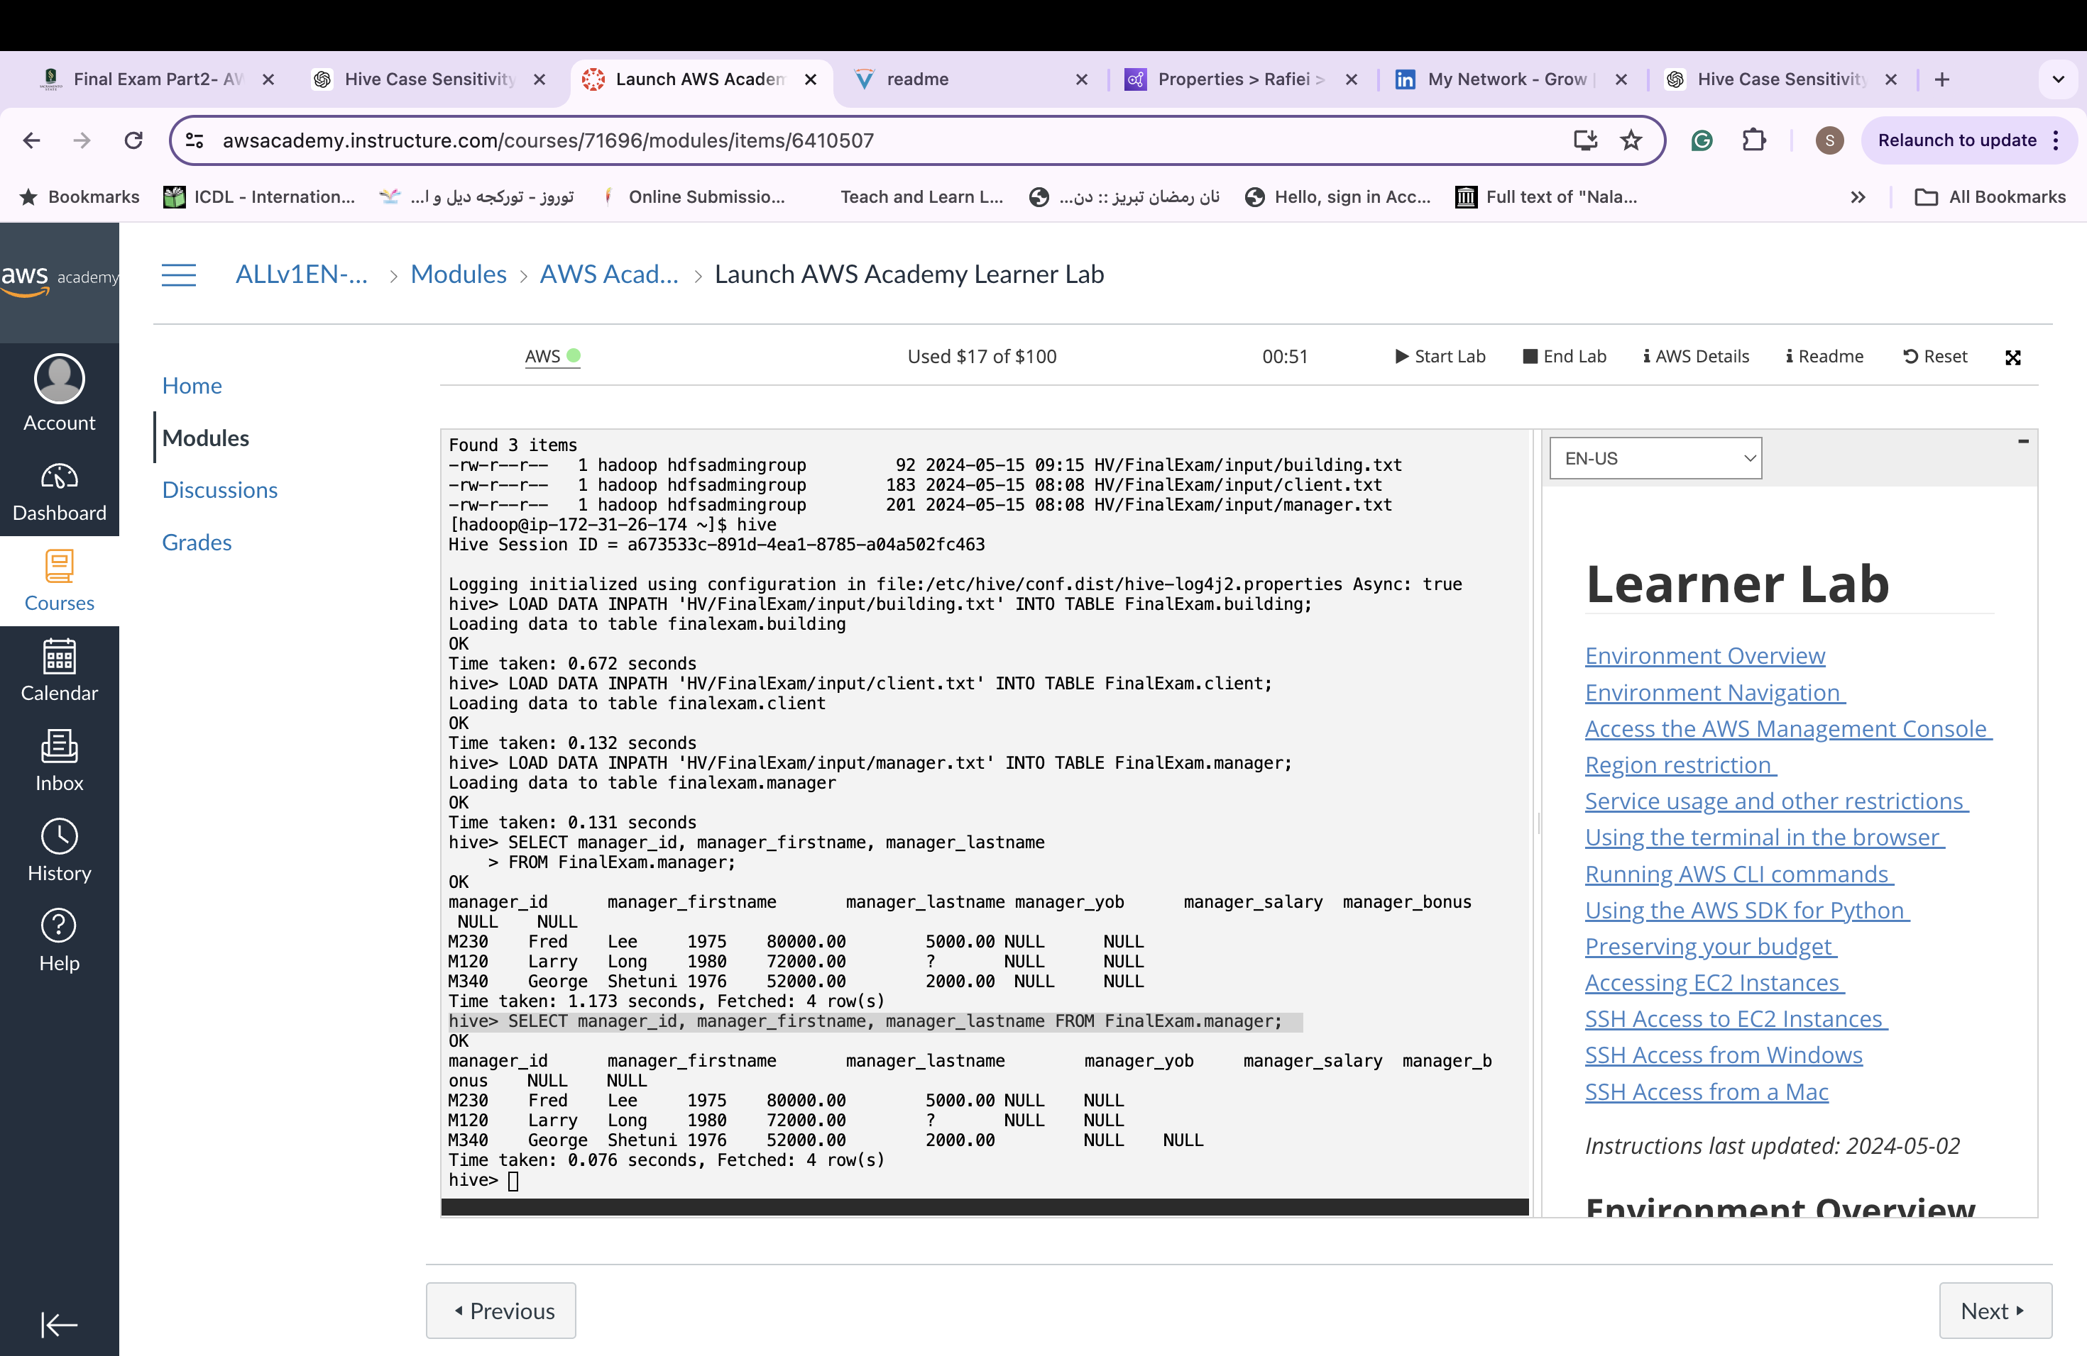

* 1. Display the list of all clients, including their id, name, and industry.

* 1. Display the hotel building id, the number of floors, and the

manager's first name and last name for each hotel.

* 1. Display the manager's first and last name, as well as salary, date of birth, and the number of hotel buildings that the manager manages for all managers with a salary higher than $70,000.

